LAB EXPERIMENT 8

AIM

To design and develop an Online Hospital Appointment Booking System using HTML, CSS, and JavaScript that allows patients to search hospitals and doctors by specialty and location, book and cancel appointments, view appointment status, manage medical appointment history, and provide doctor reviews. The system also enables administrators to manage doctors, hospitals, appointments, and patient feedback.

PROCEDURE
- Create a project folder and create an HTML file named index.html.
- Use HTML to design the structure of the hospital appointment booking website.
- Use CSS to create an attractive and responsive user interface.
- Use JavaScript to implement hospital searching, doctor searching, and specialty filtering.
- Create a patient registration and login interface.
- Develop an appointment booking form to select doctors, dates, and available time slots.
- Implement features to view appointment status, cancel appointments, and check appointment history.
- Create an admin panel to manage hospitals, doctors, appointments, and patient reviews.
- Add a feedback form for patients to rate doctors and share their experiences.
- Open the index.html file in a web browser and test the system's features
<!DOCTYPE html>
<html lang="en">
<head>
<meta charset="UTF-8">
<meta name="viewport" content="width=device-width,initial-scale=1.0">
<title>Online Hospital Appointment System</title>
<style>
body{font-family:Arial;margin:0;background:#eef7f9;color:#333}
header{background:#087e8b;color:white;text-align:center;padding:18px}
.container{max-width:850px;margin:20px auto;padding:20px;background:white;border-radius:10px;box-shadow:0 3px 10px #0002}
h2{color:#087e8b}
label{display:block;margin-top:10px;font-weight:bold}
input,select,textarea{width:100%;box-sizing:border-box;padding:10px;margin-top:5px}
button{padding:10px 14px;margin-top:12px;background:#087e8b;color:white;border:0;border-radius:5px;cursor:pointer}
.cancel{background:#c62828}
.card{margin-top:12px;padding:12px;background:#e5f5f7;border-radius:7px}
footer{text-align:center;padding:15px}
.note{font-size:13px;color:#666}
</style>
</head>
<body>
<header><h1>Online Hospital Appointment System</h1><p>Search Hospitals | Find Doctors | Book Appointments</p></header>
<div class="container">
<h2>1. Patient Registration / Login</h2>
<label>Patient Name</label><input id="patient" placeholder="Enter your name">
<label>Email</label><input id="email" type="email" placeholder="Enter email">
<label>Phone Number</label><input id="phone" type="tel" placeholder="Enter 10-digit phone number">
<button onclick="registerPatient()">Register / Login</button>
<div id="loginMessage"></div>
<hr>
<h2>2. Search Hospitals and Doctors</h2>
<label>Search Location</label><input id="location" placeholder="e.g. Chennai">
<label>Select Specialty</label>
<select id="specialty" onchange="searchDoctors()">
<option value="All">All Specialties</option>
<option>Cardiology</option><option>Dermatology</option><option>Neurology</option><option>Orthopedics</option><option>Pediatrics</option>
</select>
<button onclick="searchDoctors()">Search</button>
<div id="doctorList"></div>
<hr>
<h2>3. Book Appointment</h2>
<label>Select Doctor</label>
<select id="doctor">
<option value="Dr. Arun">Dr. Arun - Cardiology</option>
<option value="Dr. Priya">Dr. Priya - Dermatology</option>
<option value="Dr. Kumar">Dr. Kumar - Neurology</option>
<option value="Dr. Meena">Dr. Meena - Orthopedics</option>
<option value="Dr. Ravi">Dr. Ravi - Pediatrics</option>
</select>
<label>Appointment Date</label><input id="date" type="date">
<label>Appointment Time</label>
<select id="time">
<option>09:00 AM</option><option>10:00 AM</option><option>11:00 AM</option><option>02:00 PM</option><option>03:00 PM</option><option>04:00 PM</option>
</select>
<button onclick="bookAppointment()">Book Appointment</button>
<div id="bookingMessage"></div>
<hr>
<h2>4. View / Cancel Appointments</h2>
<div id="appointments">No appointments yet.</div>
<label>Appointment ID to Cancel</label><input id="cancelId" placeholder="Enter appointment ID">
<button class="cancel" onclick="cancelAppointment()">Cancel Appointment</button>
<div id="cancelMessage"></div>
<hr>
<h2>5. Check Appointment Status</h2>
<label>Appointment ID</label><input id="statusId" placeholder="Enter appointment ID">
<button onclick="checkStatus()">Check Status</button>
<div id="statusResult"></div>
<hr>
<h2>6. Doctor Feedback</h2>
<label>Doctor Rating</label>
<select id="rating"><option value="5">5 - Excellent</option><option value="4">4 - Very Good</option><option value="3">3 - Good</option><option value="2">2 - Average</option><option value="1">1 - Poor</option></select>
<textarea id="feedback" placeholder="Write your feedback"></textarea>
<button onclick="submitFeedback()">Submit Feedback</button>
<div id="feedbackMessage"></div>
<hr>
<h2>7. Admin Panel</h2>
<button onclick="showAdmin()">View Appointment Report</button>
<div id="admin"></div>
<p class="note">Lab demo only. Patient details and appointments are stored temporarily in browser memory. This is not a real medical service and does not send actual emails or SMS messages.</p>
</div>
<footer>Online Hospital Appointment Booking System | Lab Experiment</footer>
<script>
const doctors=[
{name:"Dr. Arun",specialty:"Cardiology",hospital:"City Care Hospital",location:"Chennai",rating:4.8},
{name:"Dr. Priya",specialty:"Dermatology",hospital:"Green Life Hospital",location:"Chennai",rating:4.7},
{name:"Dr. Kumar",specialty:"Neurology",hospital:"MedCare Hospital",location:"Coimbatore",rating:4.6},
{name:"Dr. Meena",specialty:"Orthopedics",hospital:"City Care Hospital",location:"Chennai",rating:4.5},
{name:"Dr. Ravi",specialty:"Pediatrics",hospital:"MedCare Hospital",location:"Madurai",rating:4.9}
];
const appointments=[];
const feedbacks=[];
let currentPatient=null;
function registerPatient(){
const name=document.getElementById("patient").value.trim();
const email=document.getElementById("email").value.trim();
const phone=document.getElementById("phone").value.trim();
if(!name||!/^[^\s@]+@[^\s@]+\.[^\s@]+$/.test(email)||!/^[0-9]{10}$/.test(phone)){alert("Enter a valid name, email and 10-digit phone number.");return}
currentPatient={name,email,phone};
document.getElementById("loginMessage").innerHTML=`<div class="card">Welcome, ${escapeHTML(name)}! Patient details accepted.</div>`;
}
function searchDoctors(){
const location=document.getElementById("location").value.trim().toLowerCase();
const specialty=document.getElementById("specialty").value;
const results=doctors.filter(d=>(!location||d.location.toLowerCase().includes(location)||d.hospital.toLowerCase().includes(location))&&(specialty==="All"||d.specialty===specialty));
document.getElementById("doctorList").innerHTML=results.length?results.map(d=>`<div class="card"><b>${d.name}</b><p>Specialty: ${d.specialty}</p><p>Hospital: ${d.hospital}</p><p>Location: ${d.location}</p><p>Rating: ${d.rating}/5</p><button onclick="selectDoctor('${d.name}')">Select Doctor</button></div>`).join(""):"No doctors found for this search.";
}
function selectDoctor(name){document.getElementById("doctor").value=name;document.getElementById("doctor").scrollIntoView({behavior:"smooth"})}
function bookAppointment(){
if(!currentPatient){alert("Please register or log in first.");return}
const doctor=document.getElementById("doctor").value;
const date=document.getElementById("date").value;
const time=document.getElementById("time").value;
if(!date){alert("Please select an appointment date.");return}
if(date<new Date().toLocaleDateString("en-CA")){alert("Select today or a future date.");return}
if(appointments.some(a=>a.doctor===doctor&&a.date===date&&a.time===time&&a.status==="Booked")){alert("This doctor's time slot is already booked.");return}
const id="APT"+Math.floor(10000+Math.random()*90000);
const appointment={id,patient:currentPatient.name,email:currentPatient.email,doctor,date,time,status:"Booked"};
appointments.push(appointment);
document.getElementById("bookingMessage").innerHTML=`<div class="card"><h3>Appointment Booked Successfully!</h3><p>Appointment ID: ${id}</p><p>Patient: ${escapeHTML(currentPatient.name)}</p><p>Doctor: ${doctor}</p><p>Date: ${date}</p><p>Time: ${time}</p><p>Status: Booked</p></div>`;
showAppointments();
}
function showAppointments(){
const box=document.getElementById("appointments");
if(!appointments.length){box.textContent="No appointments yet.";return}
box.innerHTML=appointments.map(a=>`<div class="card"><b>ID:</b> ${a.id}<br><b>Patient:</b> ${escapeHTML(a.patient)}<br><b>Doctor:</b> ${a.doctor}<br><b>Date:</b> ${a.date}<br><b>Time:</b> ${a.time}<br><b>Status:</b> ${a.status}</div>`).join("");
}
function cancelAppointment(){
const id=document.getElementById("cancelId").value.trim();
const a=appointments.find(x=>x.id===id);
if(!a){document.getElementById("cancelMessage").textContent="Appointment ID not found.";return}
if(a.status==="Cancelled"){document.getElementById("cancelMessage").textContent="Appointment is already cancelled.";return}
a.status="Cancelled";
document.getElementById("cancelMessage").innerHTML='<div class="card">Appointment cancelled successfully.</div>';
showAppointments();
}
function checkStatus(){
const id=document.getElementById("statusId").value.trim();
const a=appointments.find(x=>x.id===id);
document.getElementById("statusResult").innerHTML=a?`<div class="card">Appointment ID: ${a.id}<br>Doctor: ${a.doctor}<br>Date: ${a.date}<br>Status: ${a.status}</div>`:'<div class="card">Appointment not found.</div>';
}
function submitFeedback(){
const feedback=document.getElementById("feedback").value.trim();
const rating=document.getElementById("rating").value;
if(!feedback){alert("Please enter feedback.");return}
feedbacks.push({rating,feedback});
document.getElementById("feedbackMessage").innerHTML='<div class="card">Thank you for your feedback!</div>';
document.getElementById("feedback").value="";
}
function showAdmin(){
document.getElementById("admin").innerHTML=`<div class="card"><p>Total Appointments: ${appointments.length}</p><p>Booked: ${appointments.filter(a=>a.status==="Booked").length}</p><p>Cancelled: ${appointments.filter(a=>a.status==="Cancelled").length}</p><p>Feedback Received: ${feedbacks.length}</p></div>`;
}
function escapeHTML(value){
return String(value).replace(/[&<>"']/g,c=>({"&":"&amp;","<":"&lt;",">":"&gt;",'"':"&quot;","'":"&#39;"}[c]));
}
searchDoctors();
</script>
</body>
</html>

IMPLEMENTATION
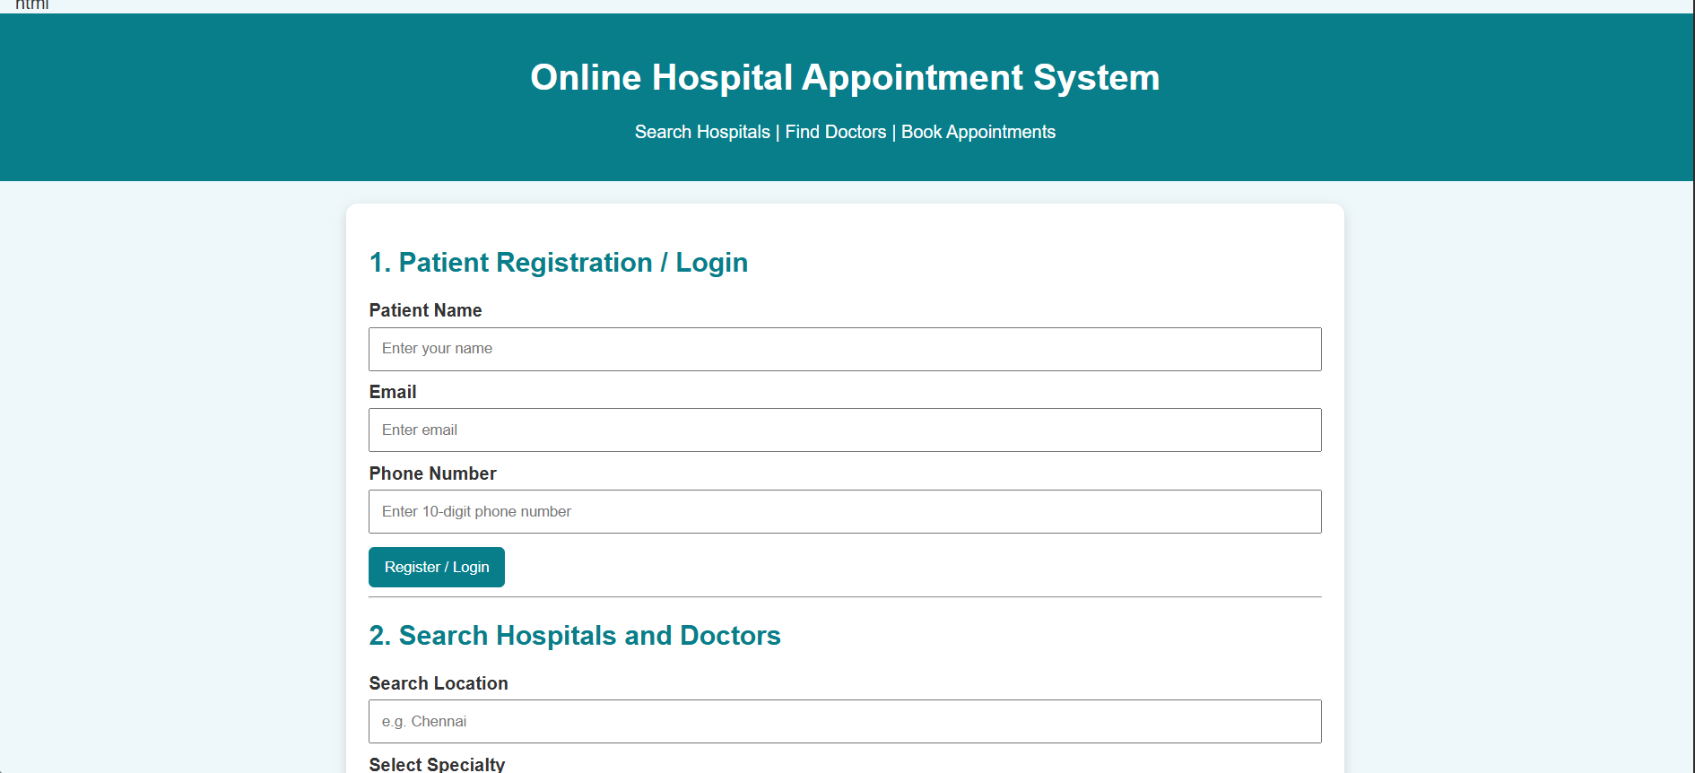
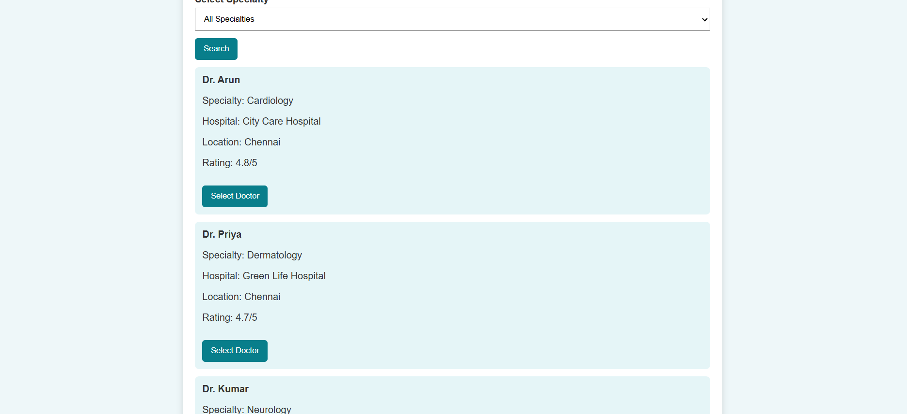

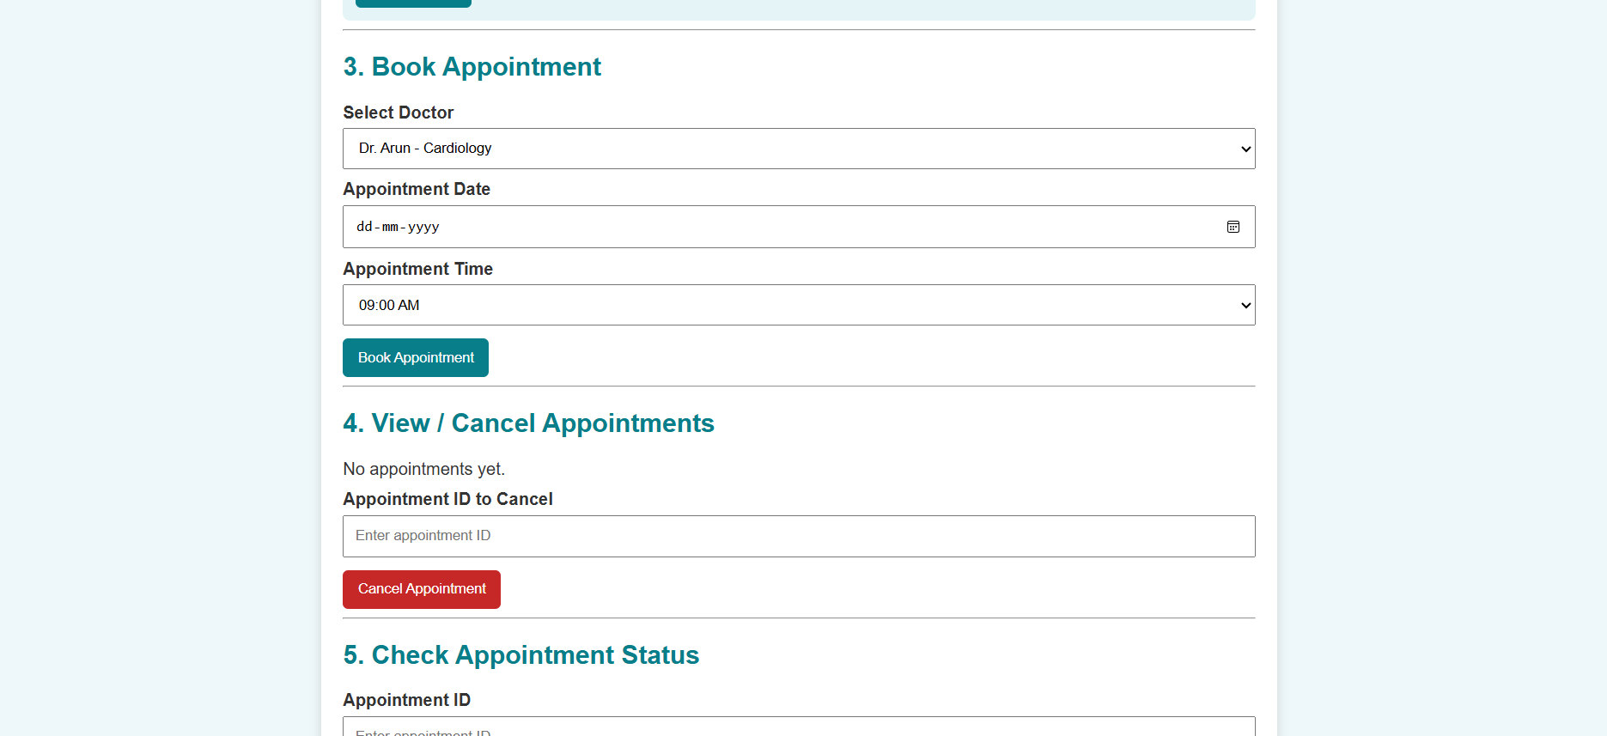

RESULT
Thus, the Online Hospital Appointment Booking System was successfully designed and implemented using HTML, CSS, and JavaScript. The system allows patients to search hospitals and doctors by location and specialty, book and cancel appointments, check appointment status, view appointment history, and provide doctor ratings and feedback. The admin panel enables the management of appointments and the viewing of appointment statistics through a user-friendly interface.

